**Problem 1**

Okay, here I solved the problem using the formula for Standard deviation which is

s = σ / √n

The answer would be (b)

Nearly normal, mean = 30000$, SD = 800$

**Problem 2**

Here is a research article I found

# **The level of non-citation of articles within a journal as a measure of quality: a comparison to the impact factor**

Total citations gained by October 2003, for every original article and review published in current immunology (13125 articles; 105 journals) and surgical (17083 articles; 120 journals) fields during 2001 were collected using ISI® Web of Science.

The distribution of citation of articles within an individual journal is mainly non-parametric throughout the literature. One sixth (16.7%; IQR 13.6–19.2) of articles in a journal accrue half the total number of citations to that journal. There was a broader distribution of citation to articles in higher impact journals and in the field of immunology compared to surgery. 23.7% (IQR 14.6–42.4) of articles had not yet been cited. Levels of non-citation varied between journals and subject fields. There was a significant negative correlation between the proportion of articles never cited and a journal's impact factor for both immunology (rho = -0.854) and surgery journals (rho = -0.924).

The distribution of citations of articles within each journal; the influence of the article type and length on citation, and the relationship between proportion of non-cited articles within a journal and its Impact factor were investigated.

In the 198 journals which publish the bulk of articles (>95%) the distribution of citations amongst articles was non parametric. Histograms for a sample of 5 primary research immunology journals are shown in Figure [1](https://bmcmedresmethodol.biomedcentral.com/articles/10.1186/1471-2288-4-14#Fig1).

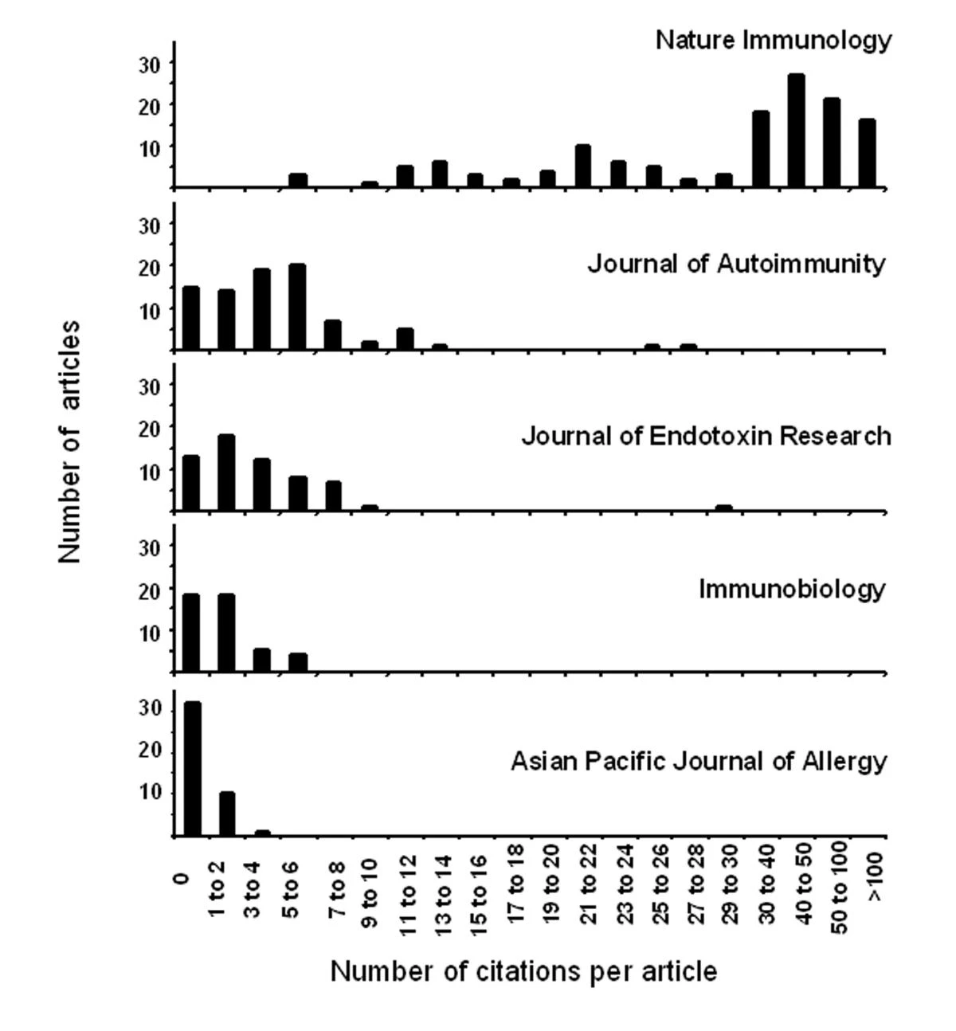

Despite these limitations, citation counts provide a convenient and objective method of ranking articles and journals. It is therefore important to use the most appropriate and transparent way of communicating this information, particularly if such rankings are used to define quality.

**Problem 3**

# **The Use of Cronbach’s Alpha When Developing and Reporting Research Instruments in Science Education**

# Science education research often involves the adoption of existing, or the development of new, instruments to measure phenomena of interest. In the present paper, two particular types of instrument are considered, scales and tests. Scales are here considered to measure constructs in the affective domain, such as attitudes. Tests are here considered to measure cognitive features such as knowledge and understanding of science concepts and topics.

*In this study, Cronbach’s coefficient α was used to calculate the internal consistency coefficients of the items included in the questionnaire through a pilot study with 42 science teachers. Results of the reliability analysis showed that the items in the six scales had a satisfactory discriminating power. (Mansour, 2015, p. 1773)*

*One paper that referred to alpha as internal consistency also used the alternative term coherence (Wild, 2015). This study, that explored chemistry learners’ perceptions of learning environment and Science, Technology, Engineering and Mathematics (STEM) career expectations, modified a previously reported instrument. When discussing the previously published instrument, alpha was described as internal consistency (“Research using the CLES with American elementary, middle, and high school students has found high internal consistency (0.93 ≤ Cronbach’s α ≤ 0.94)”, p. 2290), but when discussing the new analysis undertaken, the alternative term was used (“The perception of a CLE item showed high coherence (Cronbach’s α = 0.90)”, p. 2290) albeit in a subsection titled “Internal consistency and factor analyses”.*

Thank you

Student ID : 201923250

Name : Kobilov Ilkhomjon